**Project Design Phase-II**

**Data Flow Diagram & User Stories**

|  |  |
| --- | --- |
| Date | 24-June-2025 |
| Team ID | LTVIP2025TMID20776 |
| Project Name | Shop Smart |
| Maximum Marks | 4 Marks |

**Data Flow Diagrams:**

A **Data Flow Diagram (DFD)** illustrates how data moves within the Resolve Now platform. It captures how user interact with the system, how information flows between different components, and where the data is stored.

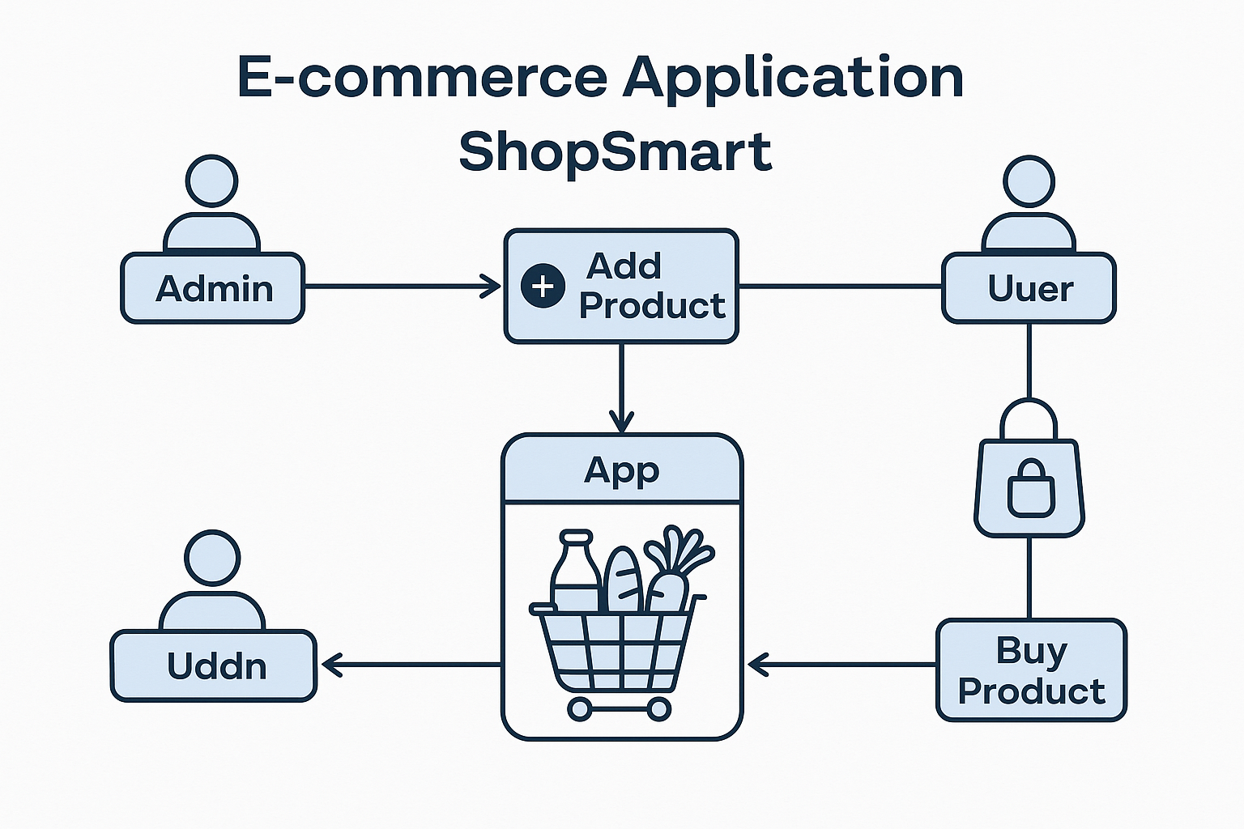

**User Story Table – Shop Smart**

|  |  |  |  |  |  |
| --- | --- | --- | --- | --- | --- |
| **User Type** | **Functional Requirement (Epic)** | **User Story / Task** | **Acceptance Criteria** | **Priority** | **Release** |
| **Admin** | |  | | --- | | Product Management | | As an admin, I can add new grocery products to the app. | Products appear in the product listing for users. | High | Sprint-1 |
| **Admin** | Inventory Control | |  |  |  | | --- | --- | --- | | |  | | --- | | As an admin, I can update or delete existing products. |  |  | | --- | |  | | | |  | | --- | | Changes are reflected in  real-time to users. |  |  | | --- | |  | | High | Sprint-1 |
| **User** | |  | | --- | | Product Browsing |  |  | | --- | |  | | |  | | --- | | As a user, I can browse all available  grocery products. |  |  | | --- | |  | | |  | | --- | | All listed products are  visible with details like  price and quantity. |  |  | | --- | |  | | Medium | Sprint-2 |
| **Client** | |  | | --- | | Add to Cart |  |  | | --- | |  | | |  | | --- | | As a user, I can add items to my  shopping cart. |  |  | | --- | |  | | |  | | --- | | Selected items appear  in the cart with correct  quantity and total. |  |  | | --- | |  | | High | Sprint-2 |
| **Admin** | |  | | --- | | Order Management |  |  | | --- | |  | | |  | | --- | | As an admin, I can view and process  user orders. |  |  | | --- | |  | | |  | | --- | | Admin dashboard shows  new orders and their  statuses. |  |  | | --- | |  | | High | Sprint-1 |